Artifacts and Testware

1-Artifacts

What Are Artifacts
# Source: Chatgpt (GPT-5-Standard) at [8/14/2025]
In software development and testing, artifacts are any by-products or deliverables created during the software development lifecycle (SDLC).
They can be documents, models, diagrams, or even code — basically, anything produced as part of the process.

Types of Artifacts

1. Process Artifacts
# Source: Chatgpt (GPT-5-Standard) at [8/14/2025]
- Describe how the project is organized and managed.
- Examples:
  - Project plans
  - Test strategies
  - Risk assessment documents

2. Product Artifacts
# Source: Chatgpt (GPT-5-Standard) at [8/14/2025]
- Represent the actual product or parts of it.
- Examples:
  - Requirements documents
  - Source code
  - Design diagrams
  - UI mockups

3. Test Artifacts
# Source: Chatgpt (GPT-5-Standard) at [8/14/2025]
- Related specifically to testing activities.
- Examples:
  - Test plans
  - Test cases
  - Test scripts
  - Bug reports

Examples in Context
# Source: Chatgpt (GPT-5-Standard) at [8/14/2025]
- Before coding: Requirements specification (artifact)
- During design: UML diagrams (artifact)
- During implementation: Source code files (artifact)
- During testing: Test case documents and defect logs (artifact)
- After release: User manuals (artifact)

Why Artifacts Matter
# Source: Chatgpt (GPT-5-Standard) at [8/14/2025]
- Provide documentation for future maintenance.
- Help ensure traceability (linking requirements → test cases → code).
- Serve as communication tools between teams.
- Can be reviewed in static testing to catch defects early.

💡 Analogy: In a construction project, artifacts are like the blueprints, safety inspection reports, and material lists — not the building itself, but essential for building it right.

2-Testware

What is Testware
# Source: Chatgpt (GPT-5-Standard) at [8/12/2025]
Testware = all the artifacts (things) produced during the testing process that are needed to design, execute, and manage tests.
It’s like “software” but for testing — created by testers and for testing.

Examples of Testware
# Source: Chatgpt (GPT-5-Standard) at [8/12/2025]
- Test plans (how testing will be done)
- Test cases & test scripts
- Test data (input values for tests)
- Test suites (grouped tests)
- Test environments (configured systems for testing)
- Defect reports
- Traceability matrices (map between requirements and tests)
- Test summary reports

Key points
# Source: Chatgpt (GPT-5-Standard) at [8/12/2025]
- Purpose: Help in planning, designing, executing, and reporting tests.
- Ownership: Usually created and maintained by testers/QA team.
- Not part of final product — but still important deliverables.
- Can be reused in future testing cycles or regression testing.

💡 Simple analogy:
If testing is a cooking process,
- Software = the actual meal (final product)
- Testware = the recipe, shopping list, cooking instructions, taste test results, and kitchen setup used to make sure the meal turns out right.

Traceability between the Test Basis and Testware
# Source: Chatgpt (GPT-5-Standard) at [8/12/2025]
Traceability between the Test Basis and Testware means being able to clearly link each testing artifact (Testware) back to the original source (Test Basis) so you can prove:
- Why you tested something
- Where a test requirement came from
- What impact a change in requirements will have on tests

Key Concepts
# Source: Chatgpt (GPT-5-Standard) at [8/12/2025]
- Test Basis = Source of truth (requirements, designs, user stories, regulations).
- Testware = All the testing artifacts you produce (test plans, test cases, scripts, test data, etc.).
- Traceability = Mapping between these two so there’s no guesswork.

Why it’s important
# Source: Chatgpt (GPT-5-Standard) at [8/12/2025]
- Ensures complete coverage (no missed requirements).
- Helps in impact analysis when requirements change.
- Shows compliance for audits or regulated industries.
- Detects orphan tests (tests with no related requirement).

How It Works
# Source: Chatgpt (GPT-5-Standard) at [8/12/2025]
Usually implemented through a Traceability Matrix:
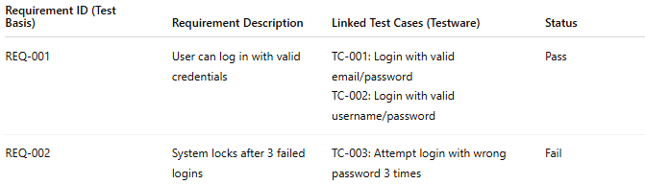
Requirement ID (Test Basis) | Requirement Description | Linked Test Cases (Testware) | Status
REQ-001 | User can log in with valid credentials | TC-001: Login with valid email/password TC-002: Login with valid username/password | Pass
REQ-002 | System locks after 3 failed logins | TC-003: Attempt login with wrong password 3 times | Fail

Example in Practice
# Source: Chatgpt (GPT-5-Standard) at [8/12/2025]
- Test Basis: Requirement REQ-045 — “Search results must be returned in under 2 seconds.”
- Testware:
  - Test Case TC-123 — Measure search response time for keyword “Laptop”.
  - Test Data — "Laptop" keyword, timing script.
- Traceability: TC-123 in the matrix links directly to REQ-045 so if REQ-045 changes (e.g., to 3 seconds), you instantly know which test cases to update.

Difference between Artifacts and Testware
# Source: Chatgpt (GPT-5-Standard) at [8/14/2025]
Here’s the clear breakdown between Artifacts and Testware so you can see the relationship and differences:

1. Artifacts
# Source: Chatgpt (GPT-5-Standard) at [8/14/2025]
- Definition:
Any by-product, document, or deliverable created during the software development lifecycle (SDLC), whether for requirements, design, coding, testing, or deployment.
- Scope:
Broad — includes all work products, not just testing-related ones.
- Examples:
  - Requirements Specification Document (SRS)
  - UML Diagrams
  - Source Code
  - Test Cases
  - Bug Reports
  - Release Notes

2. Testware
# Source: Chatgpt (GPT-5-Standard) at [8/14/2025]
- Definition:
A subset of artifacts — specifically, all materials produced during the testing process that are needed to plan, design, execute, and evaluate tests.
- Scope:
Narrow — only includes testing-related items.
- Examples:
  - Test Plans
  - Test Cases
  - Test Data
  - Test Scripts
  - Defect Logs
  - Test Reports

Key Difference Table
# Source: Chatgpt (GPT-5-Standard) at [8/14/2025]
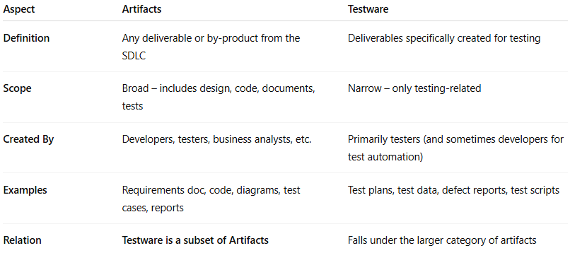
Aspect | Artifacts | Testware
Definition | Any deliverable or by-product from the SDLC | Deliverables specifically created for testing
Scope | Broad – includes design, code, documents, tests | Narrow – only testing-related
Created By | Developers, testers, business analysts, etc. | Primarily testers (and sometimes developers for test automation)
Examples | Requirements doc, code, diagrams, test cases, reports | Test plans, test data, defect reports, test scripts
Relation | Testware is a subset of Artifacts | Falls under the larger category of artifacts

💡 In short:
- Artifacts = Everything created during the project.
- Testware = The testing part of those artifacts.

